1. 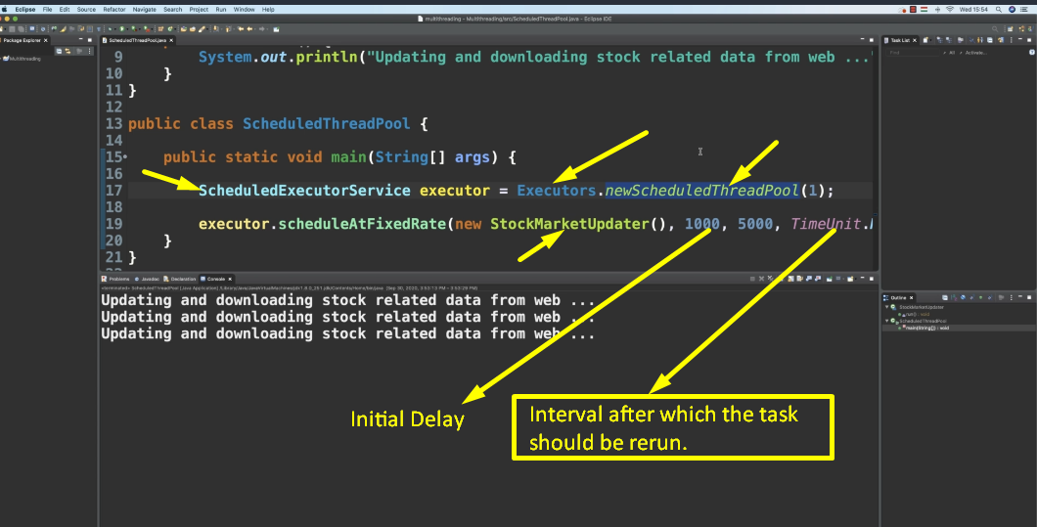
2. **Advantage**: No need to schedule your task on your own.